Week-8 Supplier Database additional queries
use sup;

SELECT p.pid, p.pname, s.sname, c.cost
FROM Catalog c
JOIN Part p ON c.pid = p.pid
JOIN Supplier s ON c.sid = s.sid
WHERE c.cost = (SELECT MAX(cost) FROM Catalog);
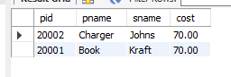
SELECT s.sname
FROM Supplier s
WHERE NOT EXISTS (
SELECT 1
FROM Catalog c
JOIN Part p ON c.pid = p.pid
WHERE c.sid = s.sid
AND p.color = 'red'
);

SELECT s.sname,
SUM(c.cost) AS total_value
FROM Supplier s
LEFT JOIN Catalog c ON s.sid = c.sid
GROUP BY s.sname;
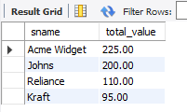
SELECT s.sname
FROM Supplier s
JOIN Catalog c ON s.sid = c.sid
WHERE c.cost < 20
GROUP BY s.sname
HAVING COUNT(*) >= 2;

SELECT p.pid, p.pname, s.sname, c.cost
FROM Catalog c
JOIN Part p ON c.pid = p.pid
JOIN Supplier s ON c.sid = s.sid
WHERE c.cost = (
SELECT MIN(c2.cost)
FROM Catalog c2
WHERE c2.pid = c.pid
)
ORDER BY p.pid;
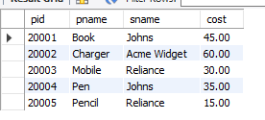
CREATE VIEW SupplierPartCount AS
SELECT s.sid, s.sname, COUNT(c.pid) AS total_parts
FROM Supplier s
LEFT JOIN Catalog c ON s.sid = c.sid
GROUP BY s.sid, s.sname;

CREATE VIEW MostExpensiveSupplierPerPart AS
SELECT c.pid, p.pname, s.sname, c.cost
FROM Catalog c
JOIN Part p ON c.pid = p.pid
JOIN Supplier s ON c.sid = s.sid
WHERE c.cost = (
SELECT MAX(c2.cost)
FROM Catalog c2
WHERE c2.pid = c.pid
);

DELIMITER $$

CREATE TRIGGER prevent_low_cost
BEFORE INSERT ON Catalog
FOR EACH ROW
BEGIN
IF NEW.cost < 1 THEN
SIGNAL SQLSTATE '45000'
SET MESSAGE_TEXT = 'Cost cannot be less than 1';
END IF;
END$$

DELIMITER ;

DELIMITER $$
CREATE TRIGGER set_default_cost
BEFORE INSERT ON Catalog
FOR EACH ROW
BEGIN
IF NEW.cost IS NULL THEN
SET NEW.cost = 50;
END IF;
END$$

